Vishaal sv – 192412349 ECA0502 EMF

EXP 4
Analysis of Continuous Charge Distribution in electric field. To find the (i) line charge
density, (ii) Surface charge density and (iii) Volume charge density for any specific (a) line,
(b) surface or (c) volume. PROGRAM:
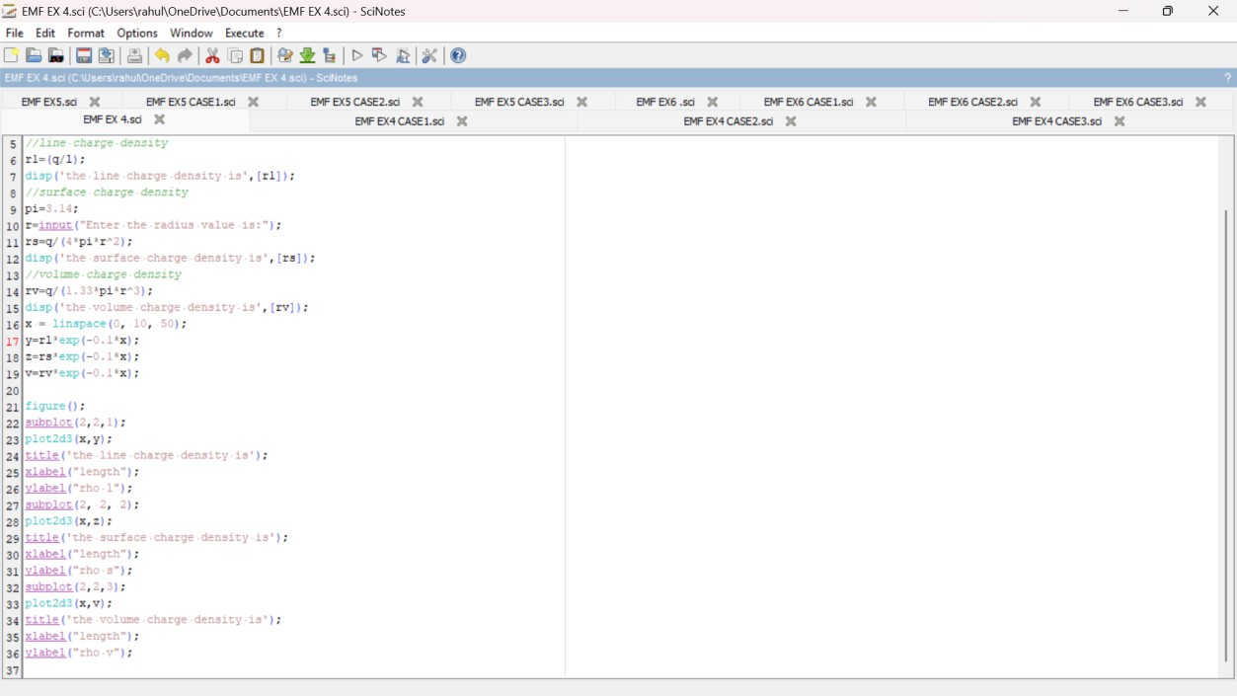

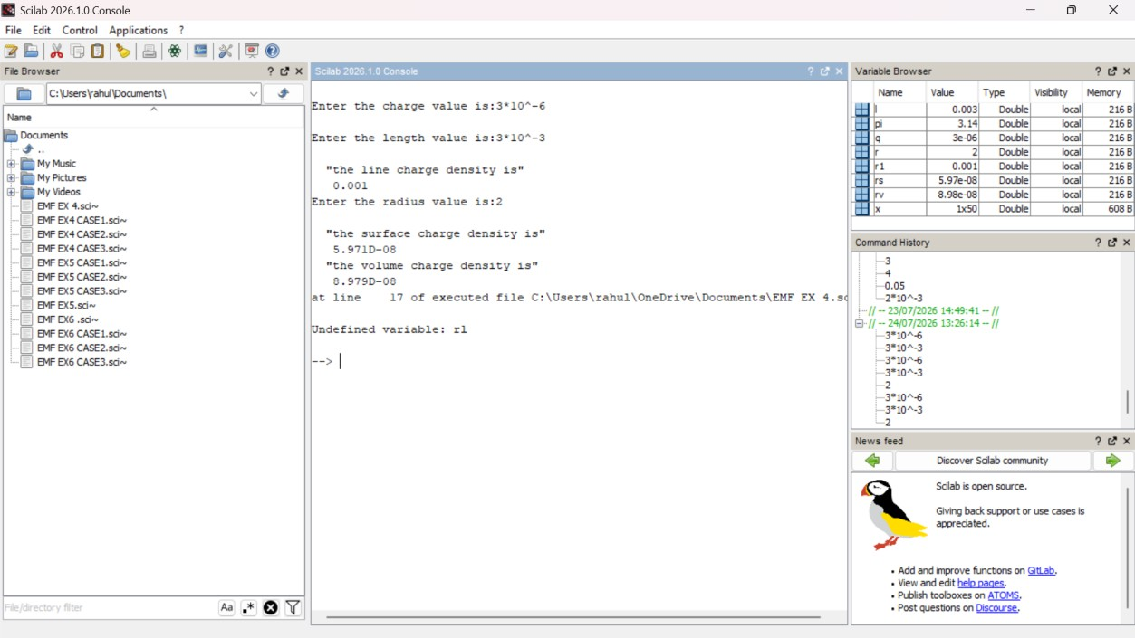
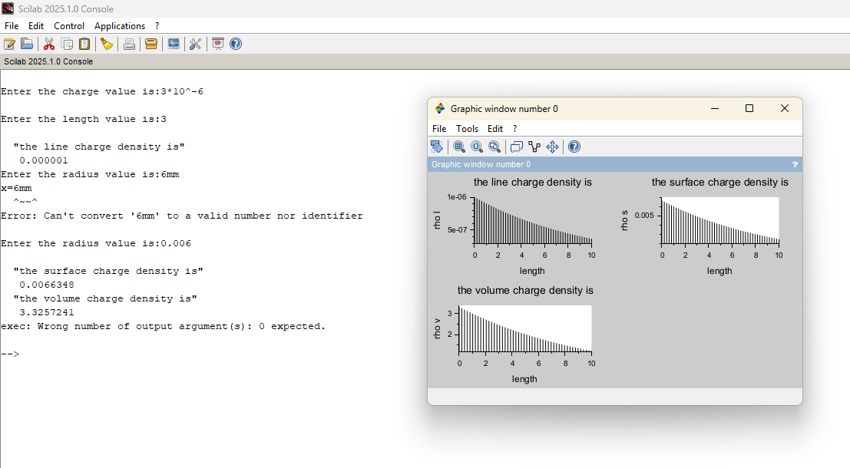OUTPUT:
OBSERVATION:

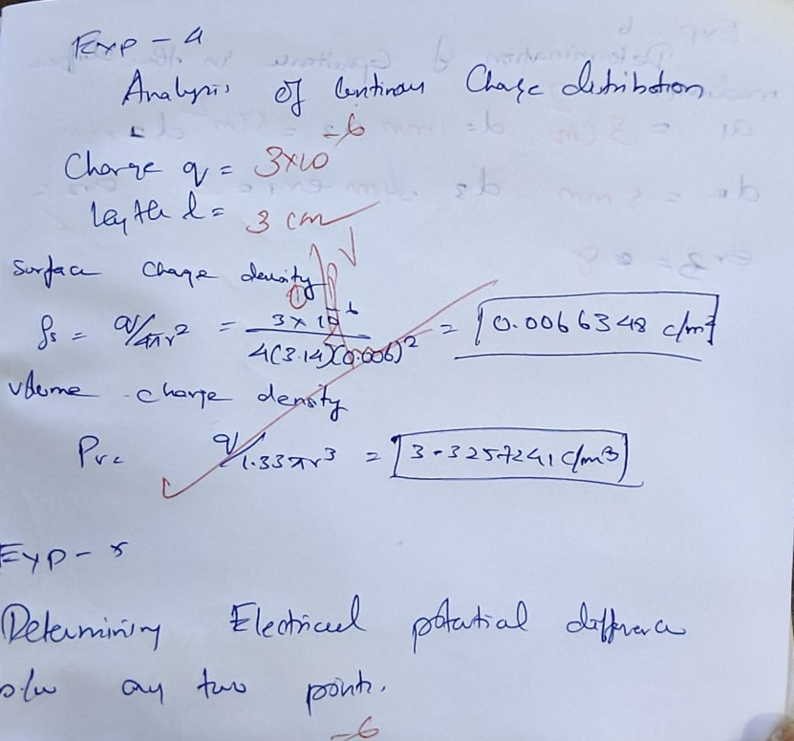

CASE 1:
PROGRAM AND OUTPUT:
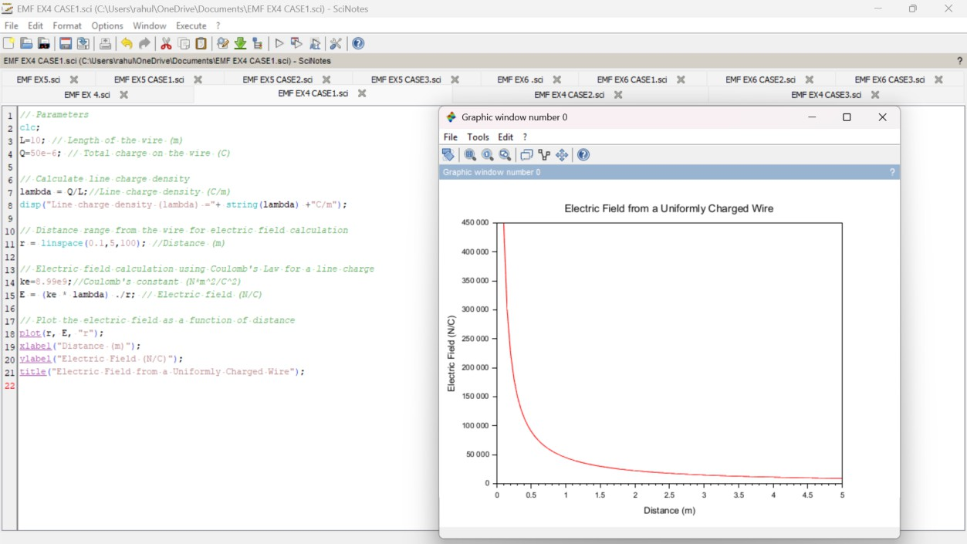

CASE 2:
PROGRAM AND OUTPUT:
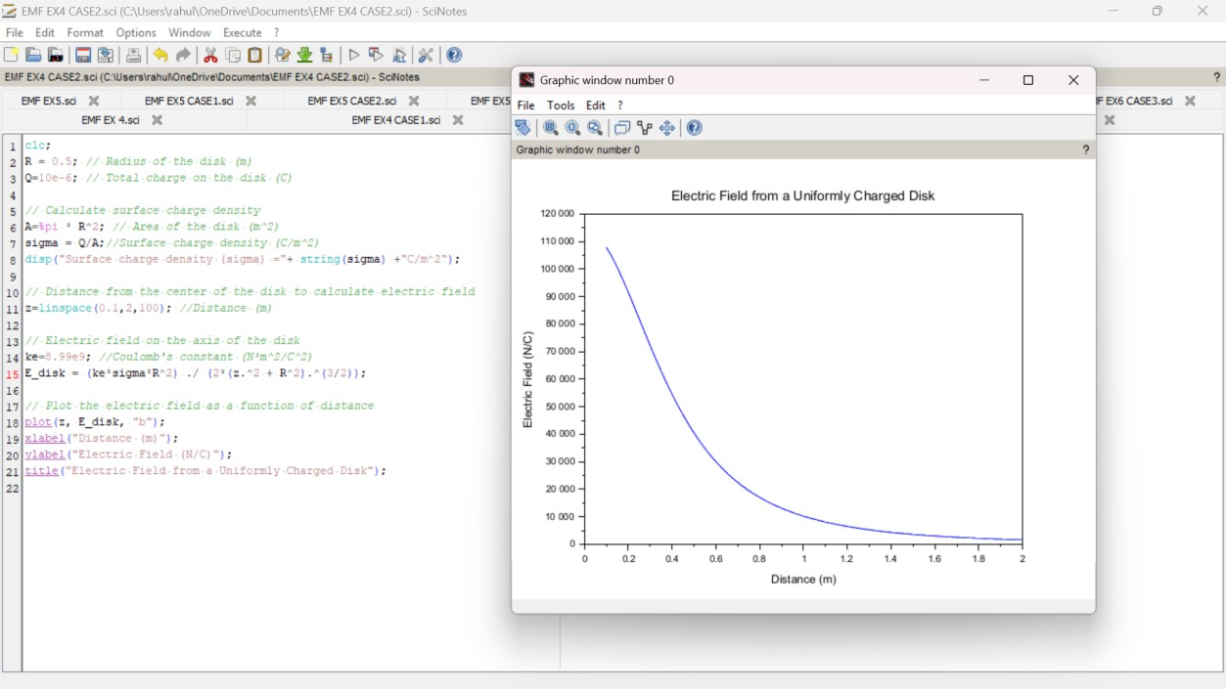

CASE 3:
PROGRAM AND OUTPUT
